PRACTICAL LAB :

Create an instance

Connect to AWS Create new machine
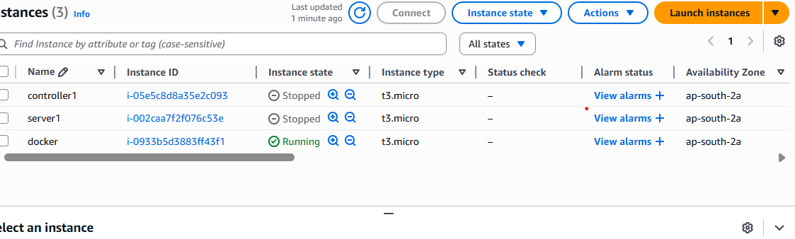

Open browser (get.docker.com)

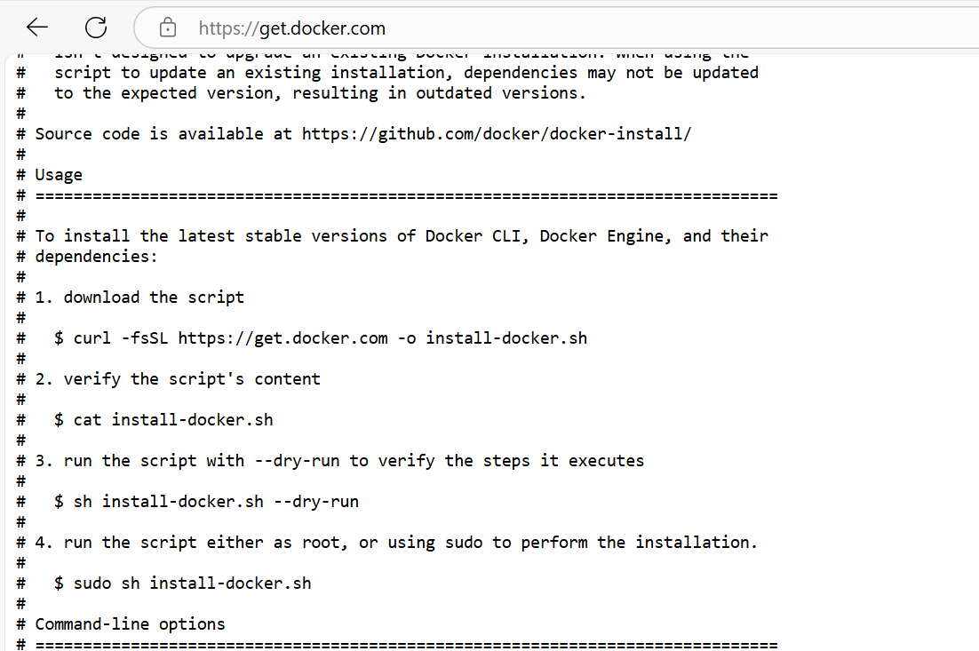

Always docker run on root user (#)
sudo su -

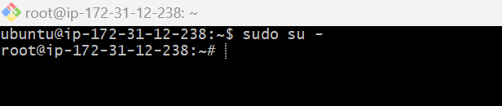

Download and install docker

curl -fsSL https://get.docker.com -o install-docker.sh
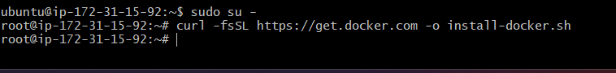

sh install-docker.sh

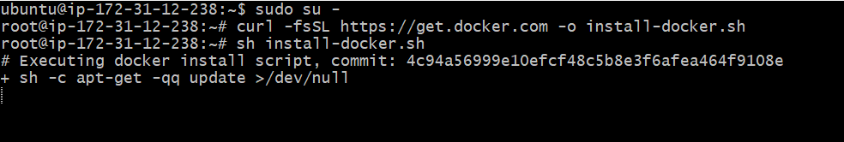

TOMCAT INSTALLATION:

#docker run --name mytomcat -p 7070:8080 tomee
docker run --name mytomcat -p 7070:8080 -d tome

Take the public ip and add 7070 to access tomcat
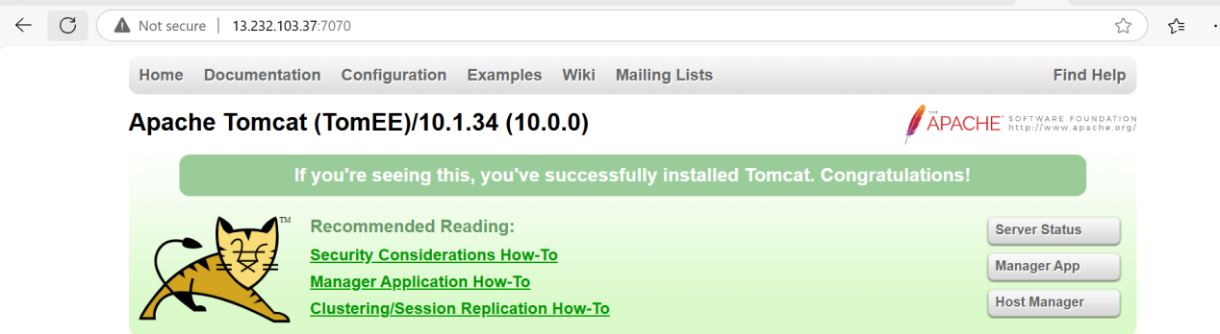

JENKINS INSTALATION:

docker run --name jenkins -p 9090:8080 jenkins/jenkins

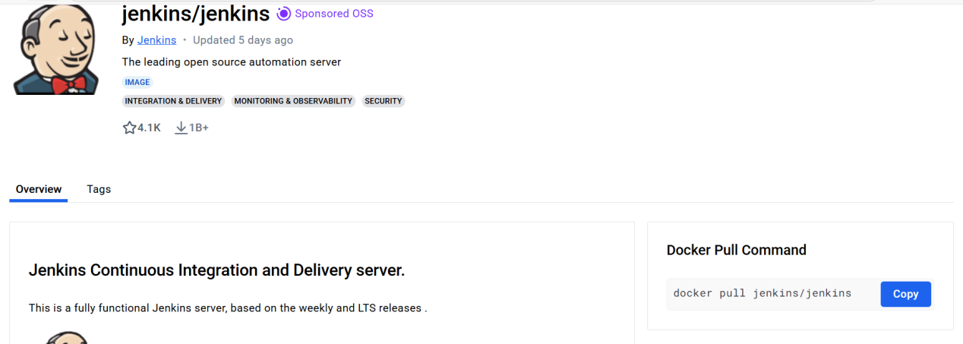

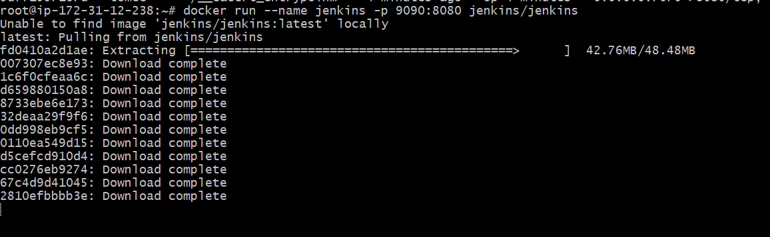

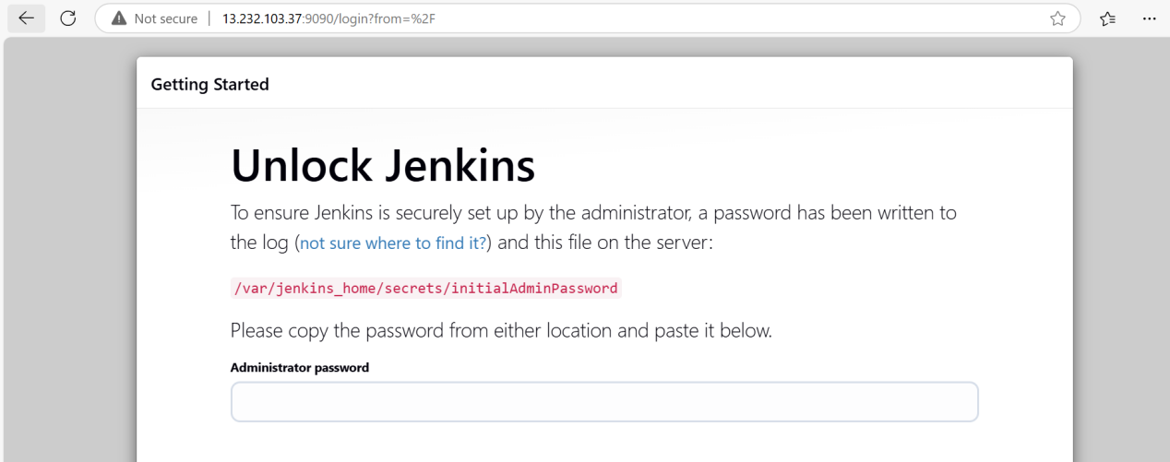

Using docker file:

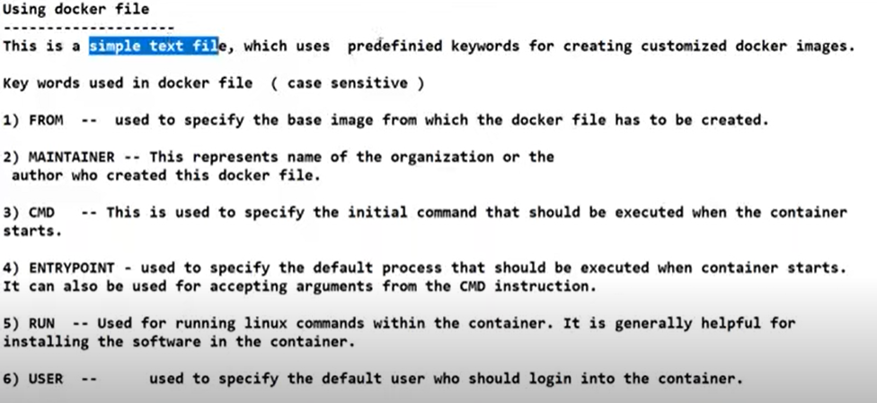
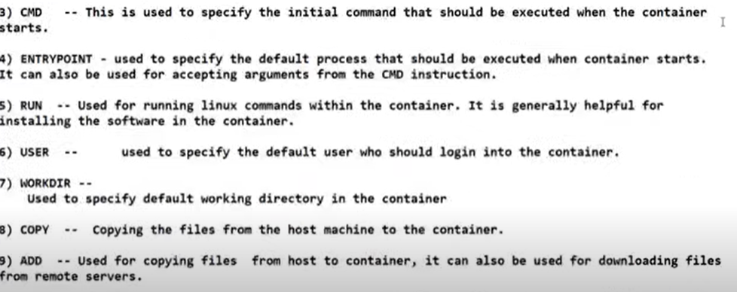

Run: is used to execute commands while building the Docker image.
Cmd: defines the default command that runs when the container starts.

Create dockerfile: vim dockerfile

FROM eclipse-temurin:17-jdk
WORKDIR /app
COPY . /app
RUN javac sample.java
CMD ["java","sample"]

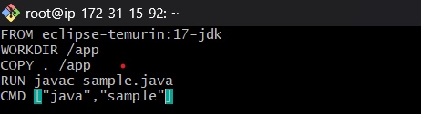
:wq
Create sample.java(calculator program)

vim sample.java

import java.util.Scanner;

class sample{
public static void main(String[] args) {

char operator;
Double number1, number2, result;

// create an object of Scanner class
Scanner input = new Scanner(System.in);

// ask users to enter operator
System.out.println("Choose an operator: +, -, *, or /");
operator = input.next().charAt(0);

// ask users to enter numbers
System.out.println("Enter first number");
number1 = input.nextDouble();

System.out.println("Enter second number");
number2 = input.nextDouble();

switch (operator) {

// performs addition between numbers
case '+':
result = number1 + number2;
System.out.println(number1 + " + " + number2 + " = " + result);
break;

// performs subtraction between numbers
case '-':
result = number1 - number2;
System.out.println(number1 + " - " + number2 + " = " + result);
break;

// performs multiplication between numbers
case '*':
result = number1 * number2;
System.out.println(number1 + " * " + number2 + " = " + result);
break;

// performs division between numbers
case '/':
result = number1 / number2;
System.out.println(number1 + " / " + number2 + " = " + result);
break;

default:
System.out.println("Invalid operator!");
break;
}

input.close();
}
}

Install java

apt-get install openjdk-17-jdk -y
compile : javac sample.java
run :java sample(sample is the file name)

Compile and run the java program
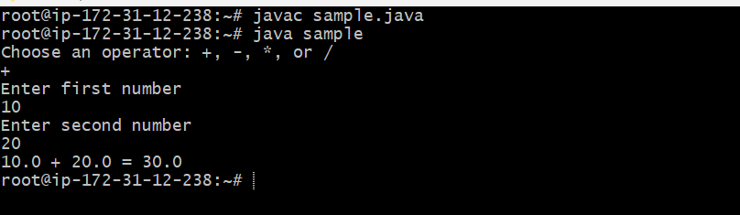

Create a dockerhub account https://hub.docker.com
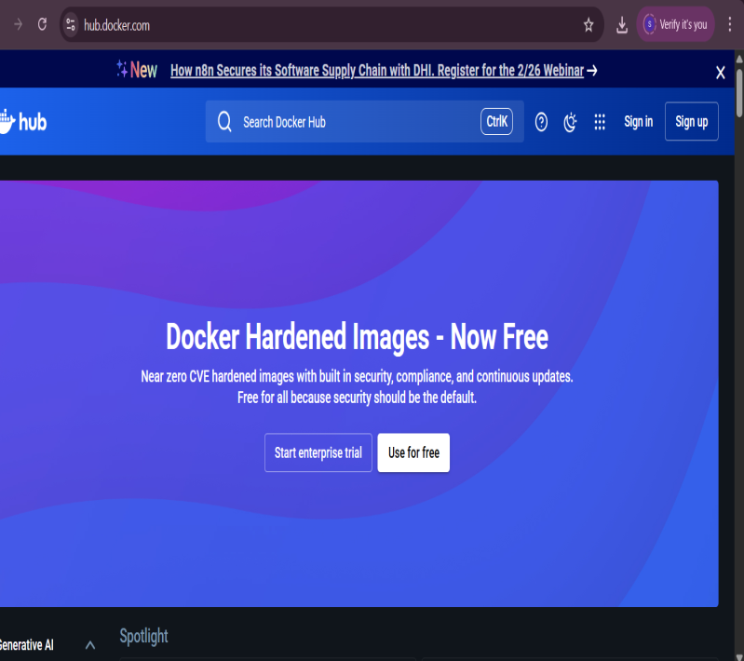
Create a docker image for the java application

docker build -t maheedhar45/javacalculator .

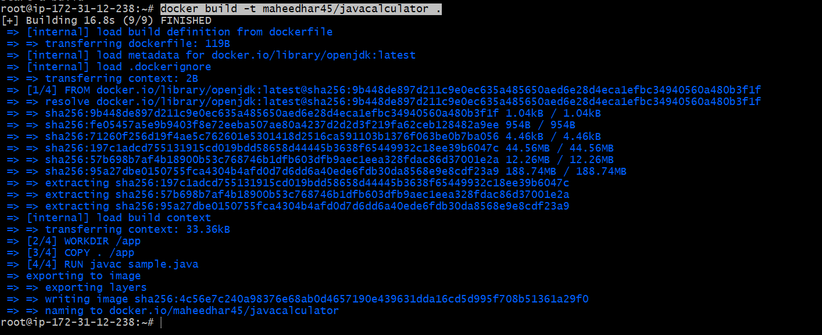

docker image ls
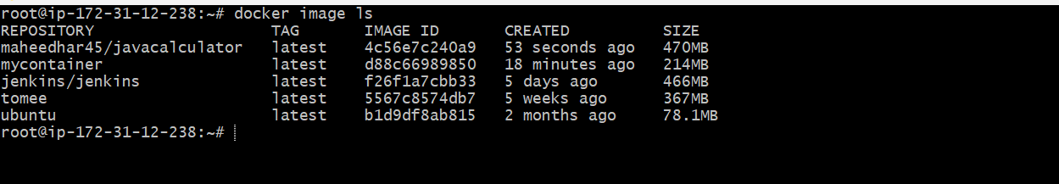

Now u push the docker image into docker hub

So create dockerhub account (hub.docker.com) (maheedhar@cmritonline.ac.in) (Welcome@1)
Login

docker login -u maheedhar45(username)
Password: Welcome@1

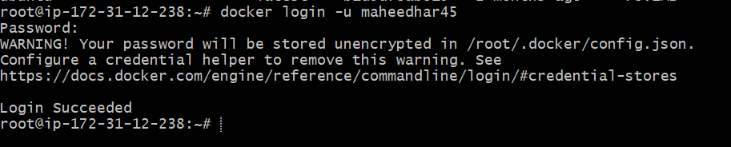

docker push maheedhar45/javacalculator

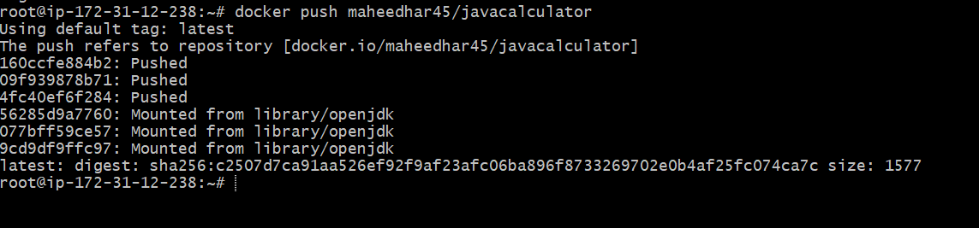

Now go and check in the docker hub

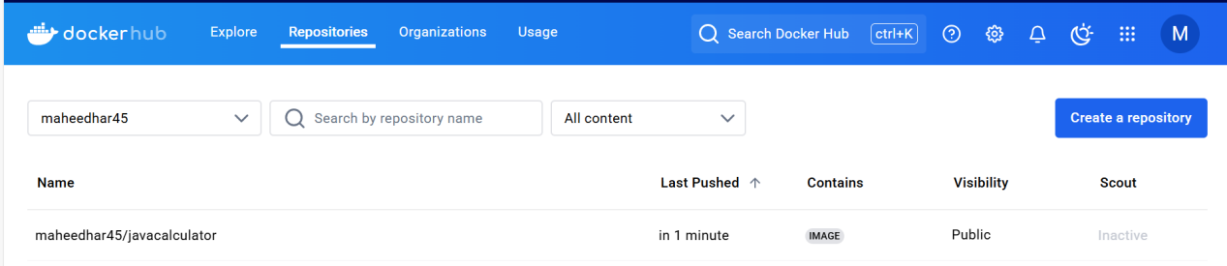

Accessing the image

docker run --name myjava -it maheedhar45/javacalculator

